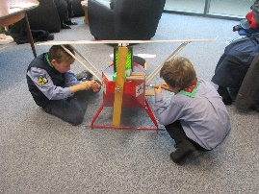
The Lakes Flying Company Ltd & Windermere Air Cadets
invite you to an

Aviation Activities Day for Young People aged 5-16
Saturday 20th April 2024
10am-12noon/ 12noon-2pm/ 2pm-4pm

At the Marchesi Centre, Holly Road, Windermere, LA23 2AF
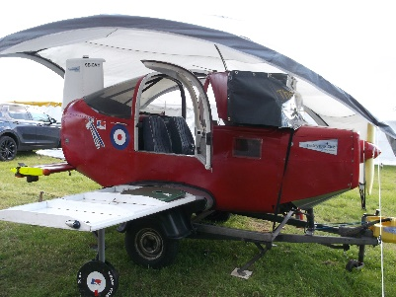
Activities include: Aeroplane full size simulator, flight simulator, radio-controlled aeroplane simulator, launch glider models build and flight, pedal plane construction, Waterbird Seaplane and Windermere aviation history, aircraft caricature and puzzles activity, identifying military aircraft which transit Windermere - and much more.
Participants under 12 years must be accompanied by an adult.

No admission charge. Three sessions as above.
Waterbird website www.waterbird.org.uk phone 07786 918176

